JavaScrip Assignment Variables

var userName;

var fullName = "Naima Hanif";

var message = "Hello World";

alert(message);

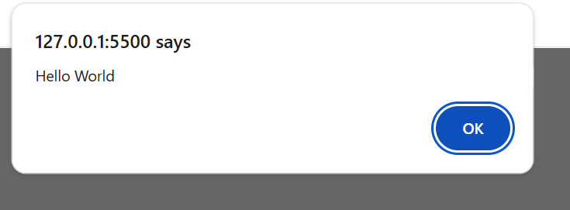

//student bio//

var name = "Neha";

var campus = "Zaitoon Ashrafi IT Park";

var course = "Web Development";

alert(name);

alert("My Campus is " + campus);

alert("Enroll course is " + course);

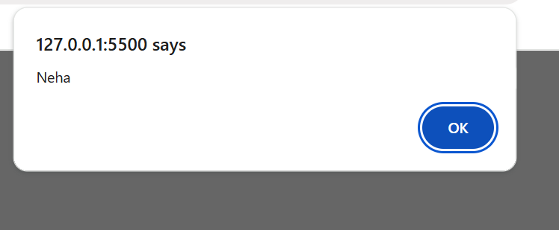

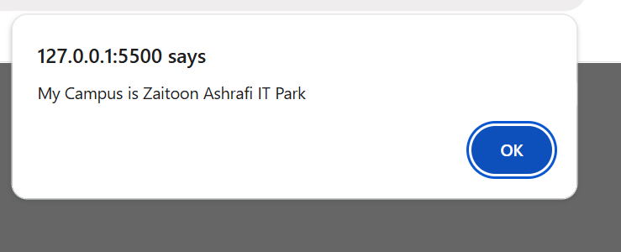

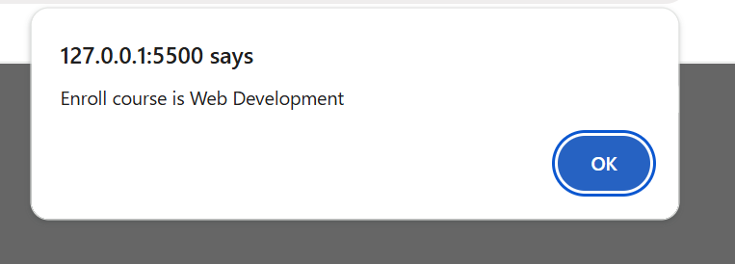

//multiple Line Alert//

var food = "Pizza\nPizz\nPiz\nPi\nP";

alert(food)

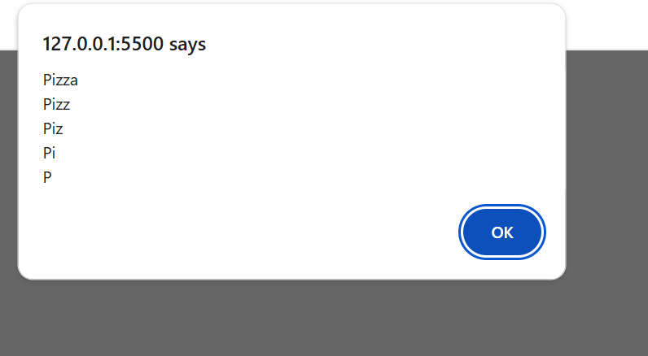

//email in Alert//

var email = "naimahanif8@gmail.com";

alert("My Email Address is " + email);

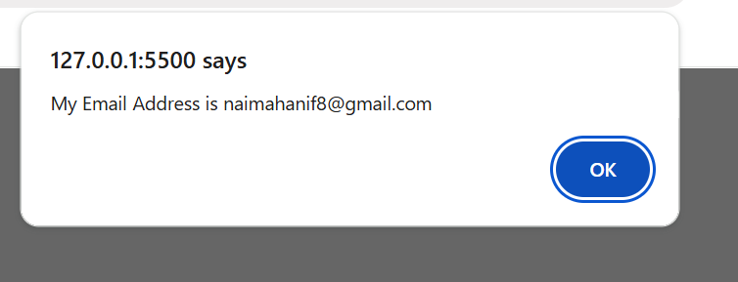

//Book in Alert//

var book = "A smarter way to learn JavaScript.";

alert("I am trying to learn from the book " + book);

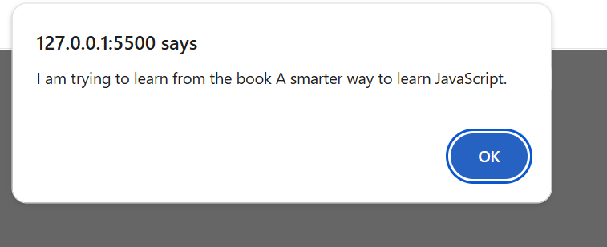

//Text in Browser//

var text = "Yah ! I can write HTML content through JavaScript";

document.write(text);

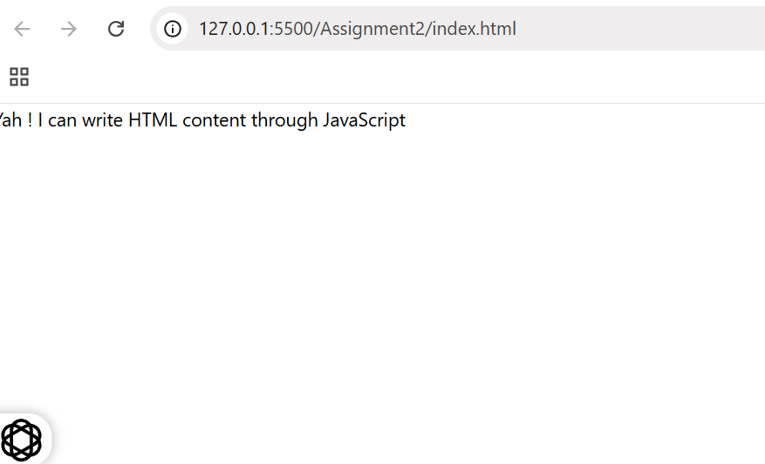

// //unicode Design//

var design = "▬▬▬▬▬▬▬▬▬ஜ۩۞۩ஜ▬▬▬▬▬▬▬▬▬";

alert(design);

document.write(design);

